SETUP ENVIRONMENT :

FLASK CREATION

|  |  |
| --- | --- |
| TEAM ID | PNT2022TMID27677 |
| TEAM LEAD | B.Nandita |
| TEAM MEMBER 01 | Faustina Philomena Fernado |
| TEAM MEMBER 02 | S.Aarthi |
| TEAM MEMBER 03 | G.V.Leaaka shree |

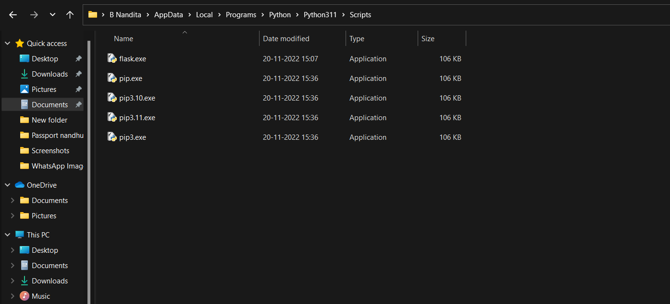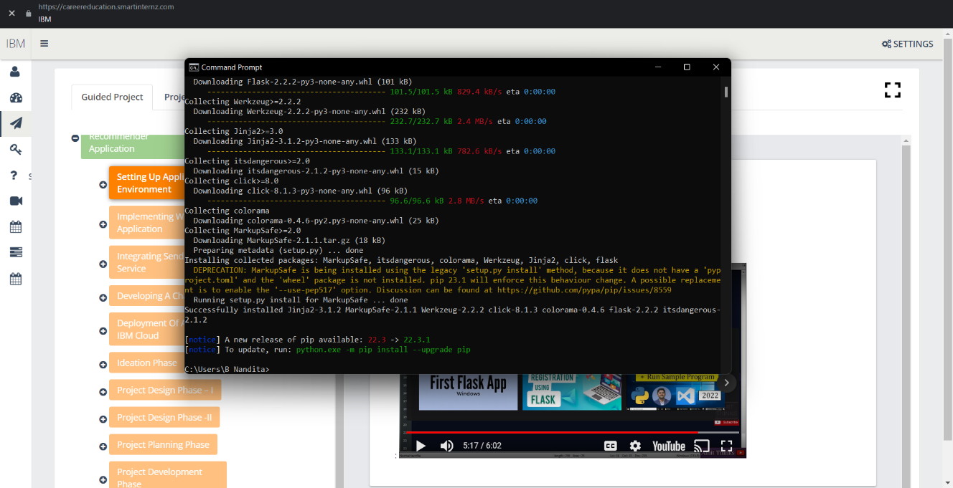**Flask install**

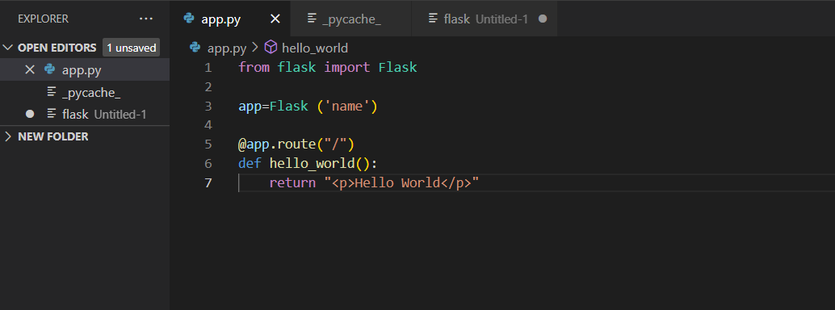**Create flask:**

**Run flask:**

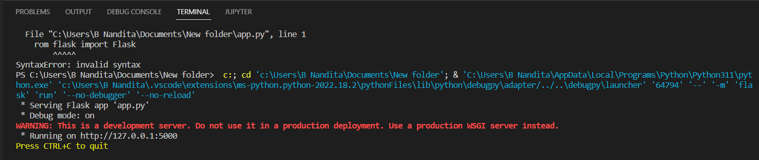

**Output**

